Healthcare Appointment
analyze patient appointment behavior

Step1 : Create and Manage Snowflake Objects
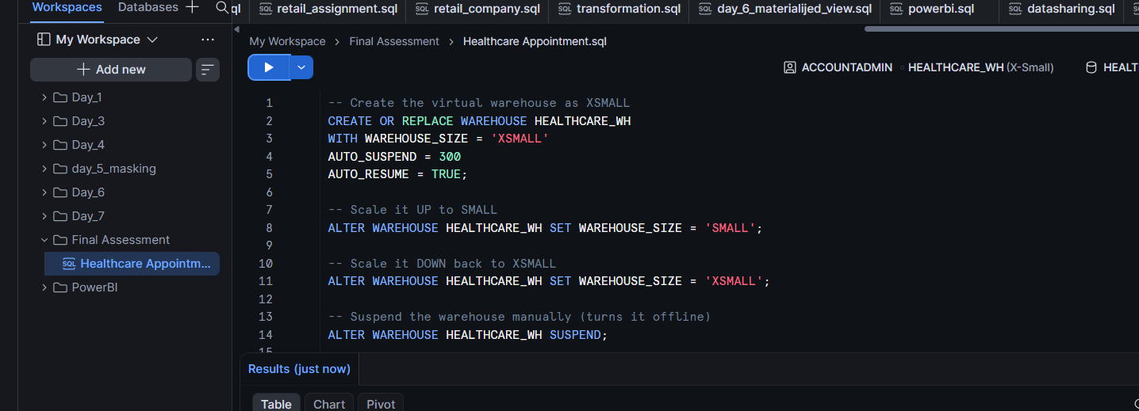
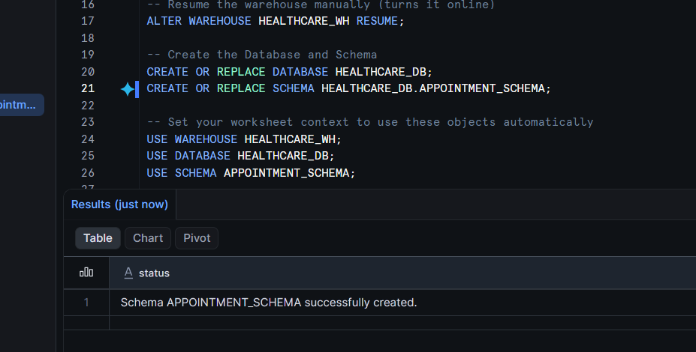
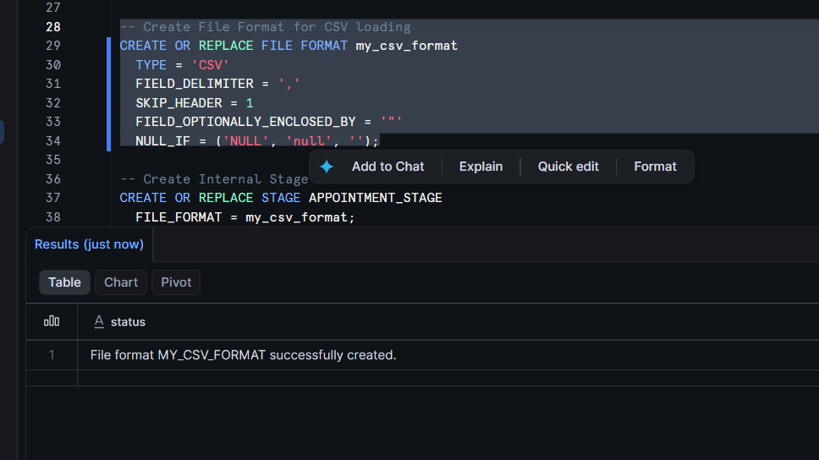

Step 2: Download Dataset
https://raw.githubusercontent.com/kb22/Medical-Appointment-No-Show-Prediction/master/data/dataset.csv
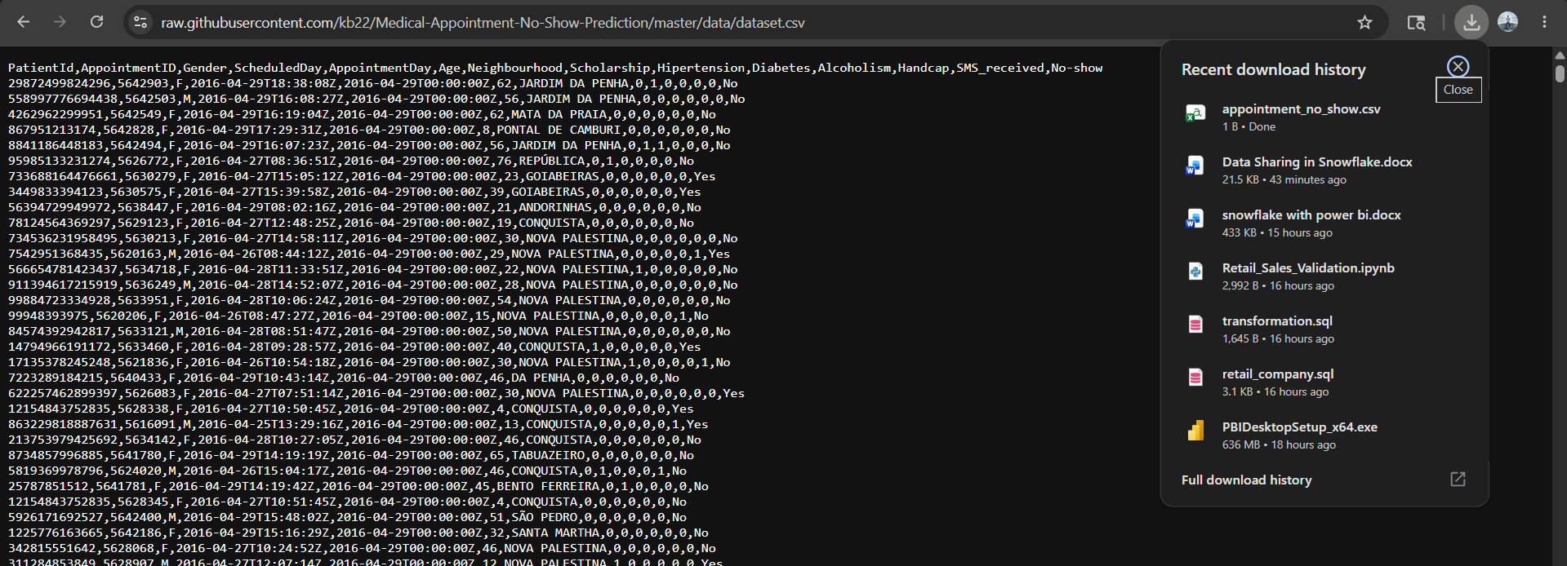

Step 3: Upload CSV into Snowflake Stage
Catalog ->Click on HEALTHCARE_DB. -> Click on APPOINTMENT_SCHEMA.->Click on Stages. -> APPOINTMENT_STAGE.

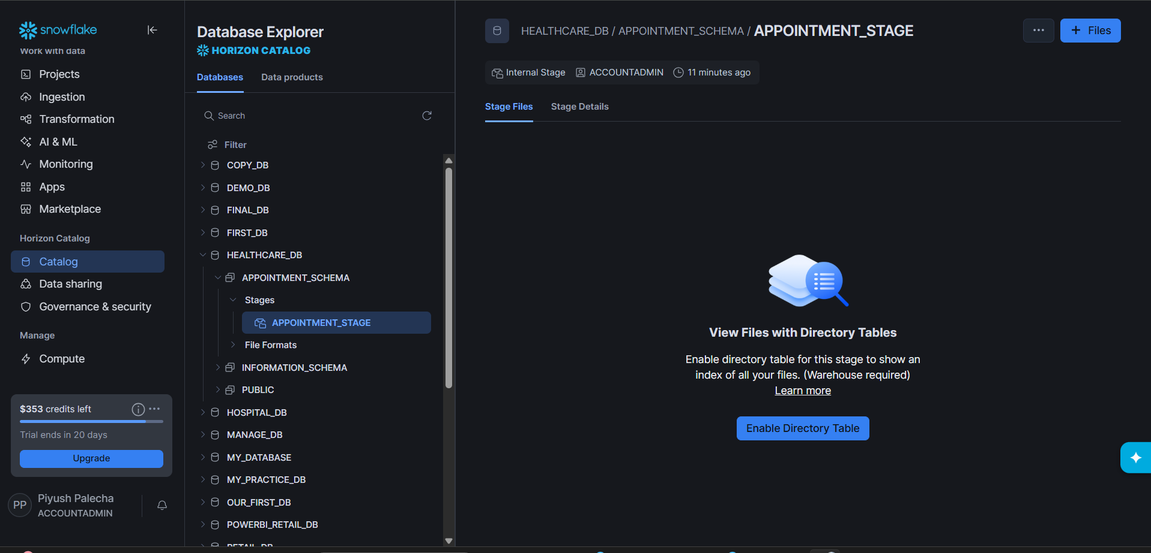
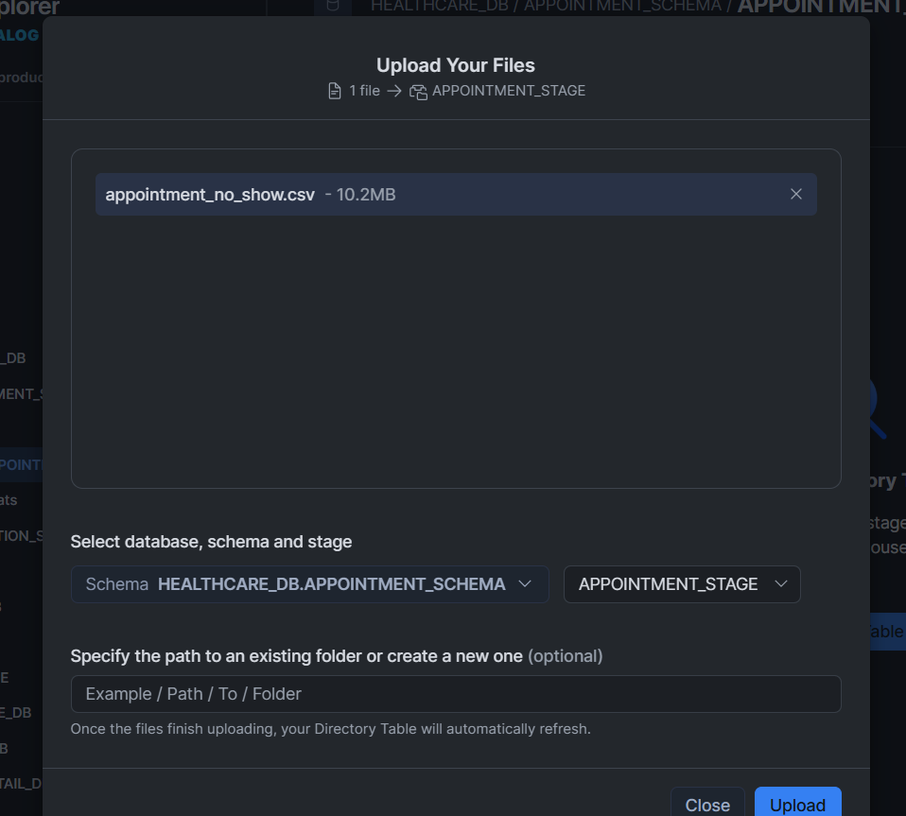
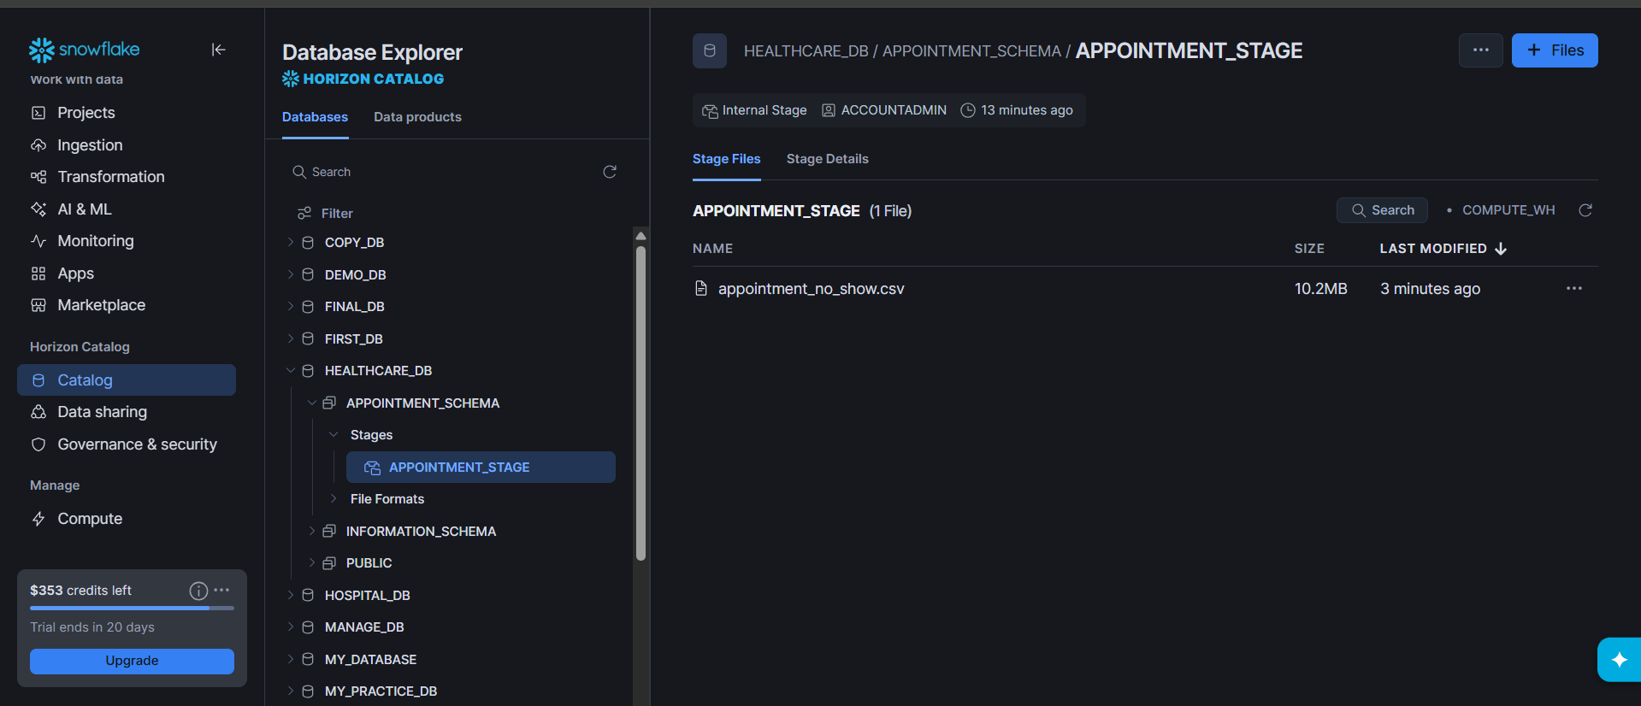

Step 5: Create Raw Table & Load Data
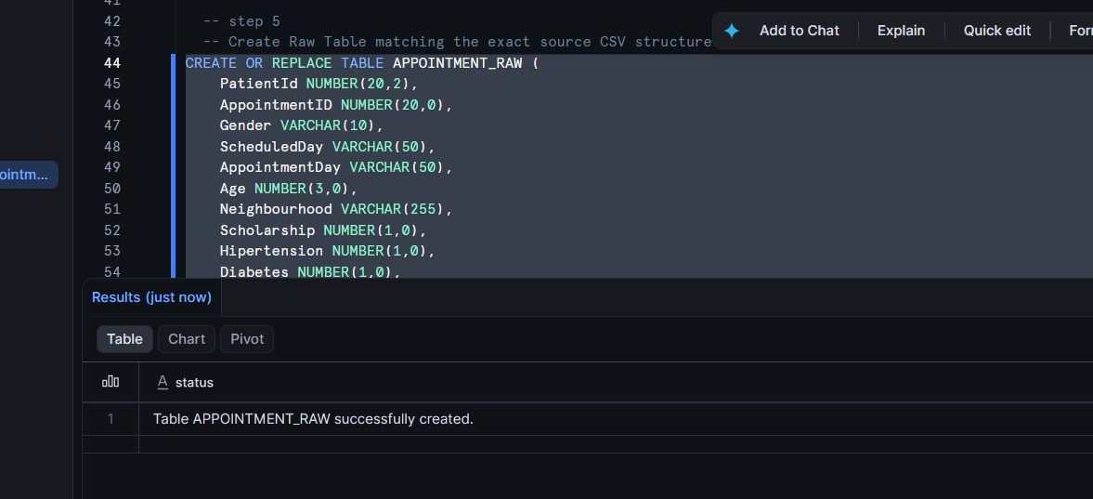
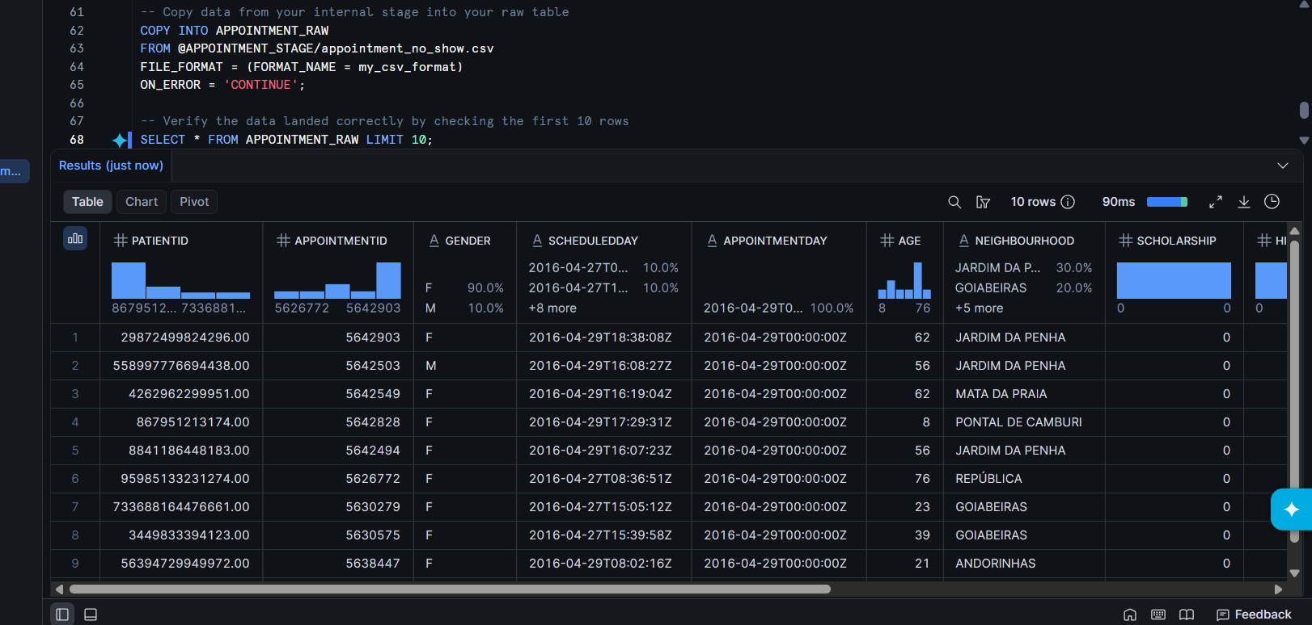
Step 6: Create Final Structured Table
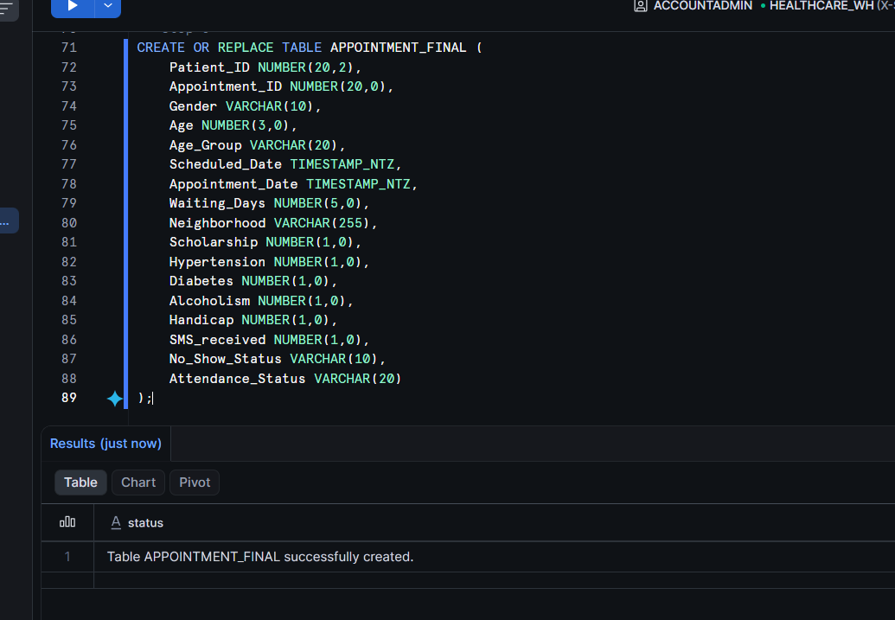

Step 7: Use Snowpark Python
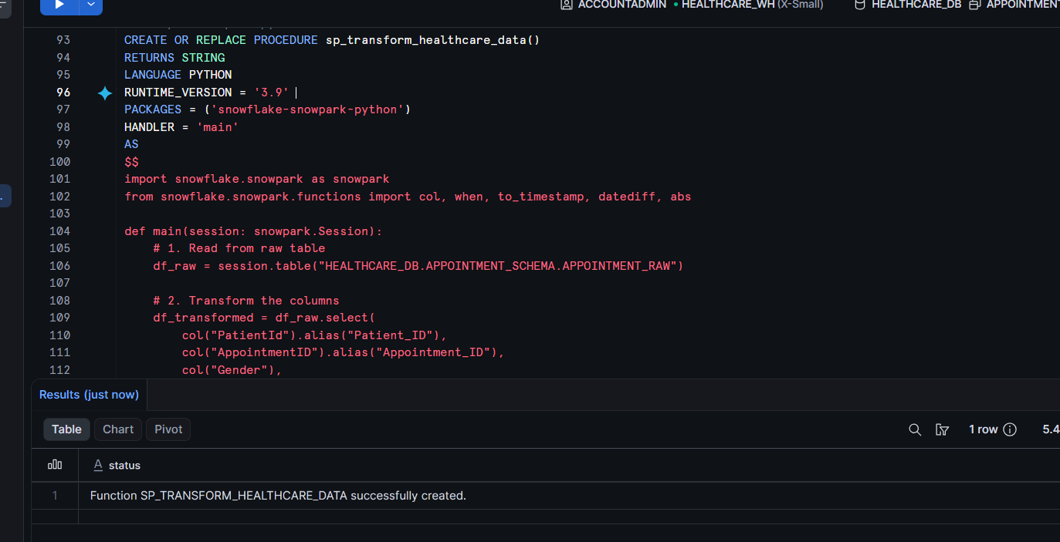
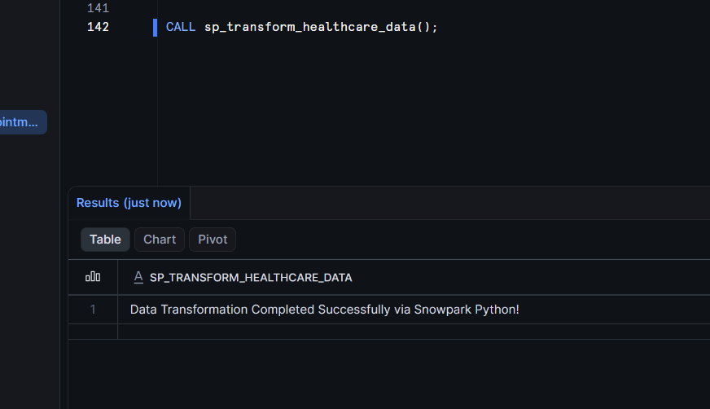
Final table output
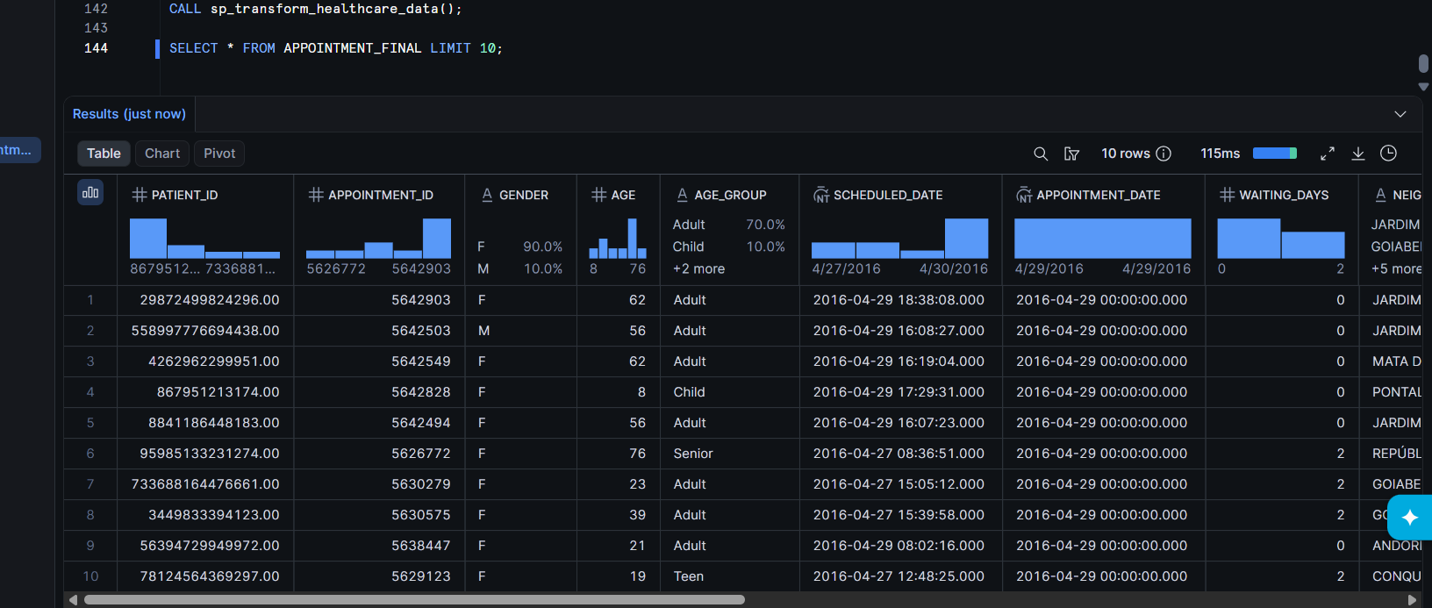

Step 8: Create Stream and use stream for incremental loading
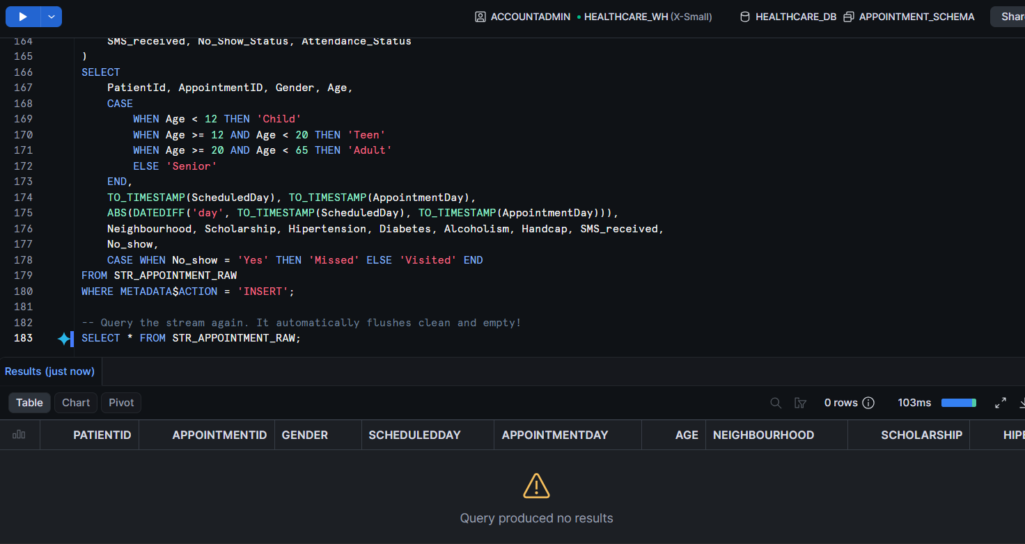
Step 9: Automated File Ingestion (Snowpipe) & Reporting View
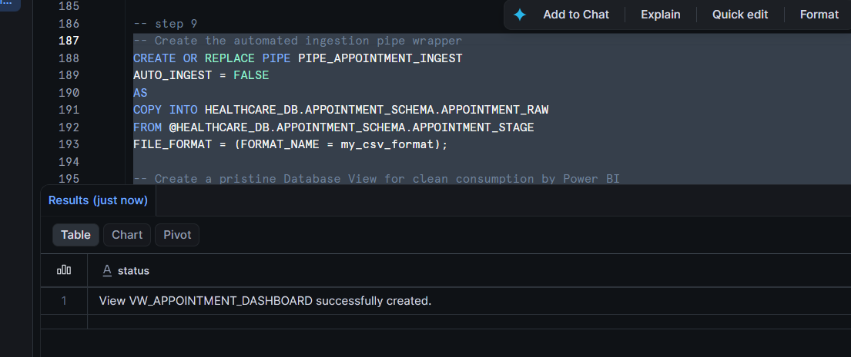
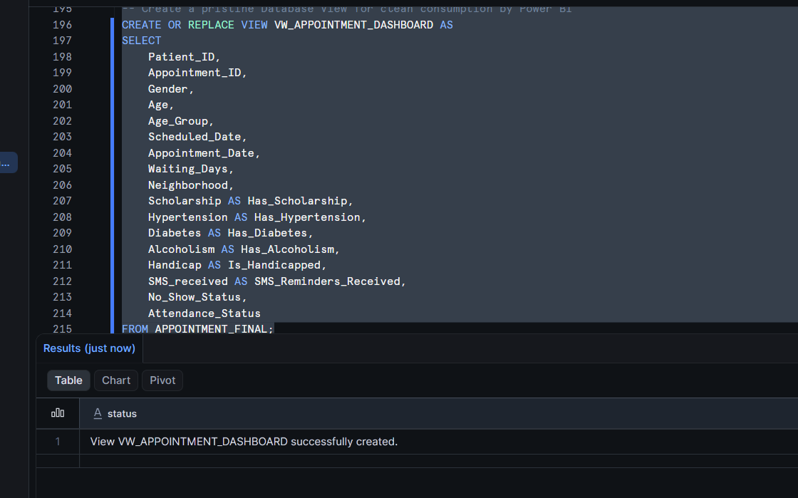

Step 10 Power Bi setup
Connect snowflake
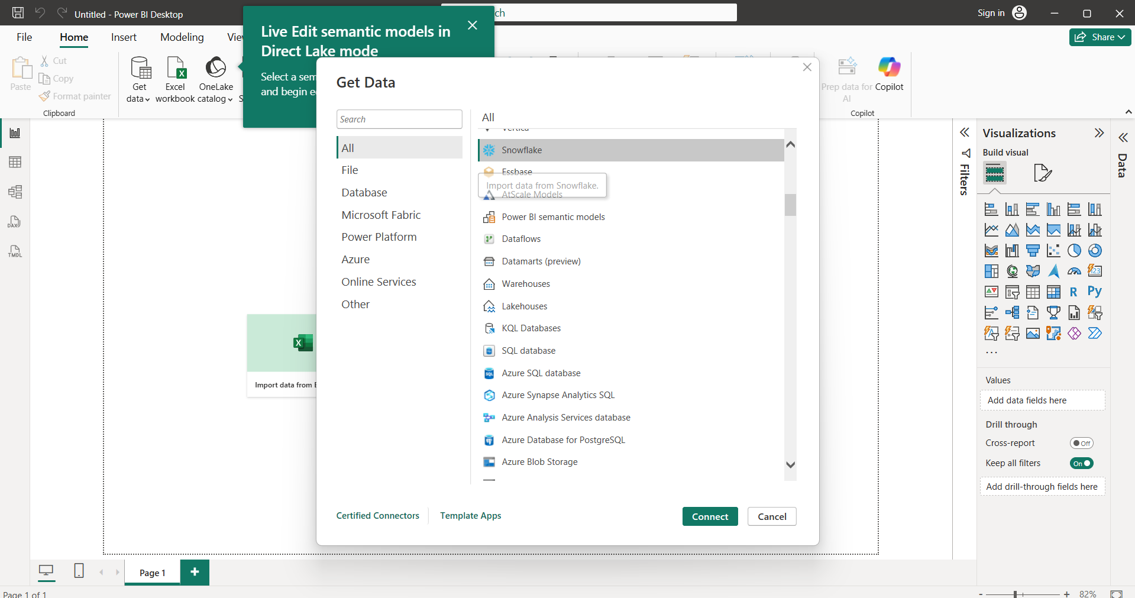

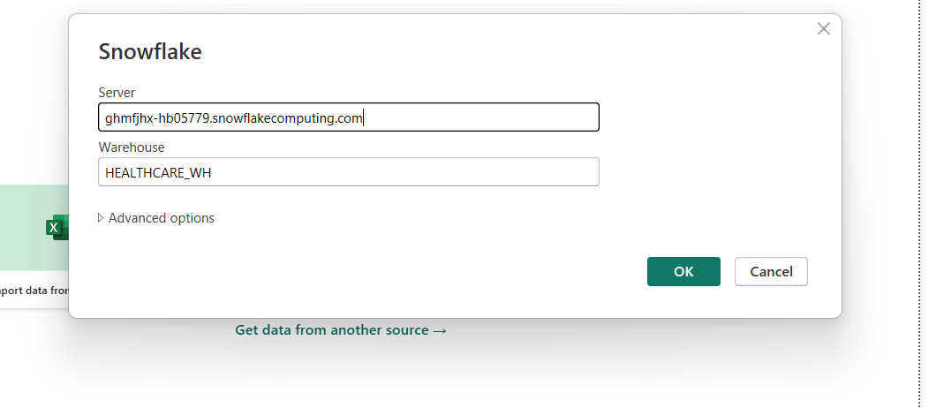
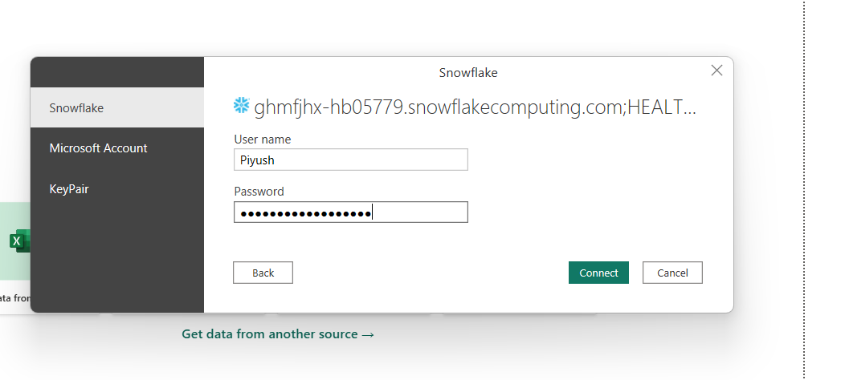

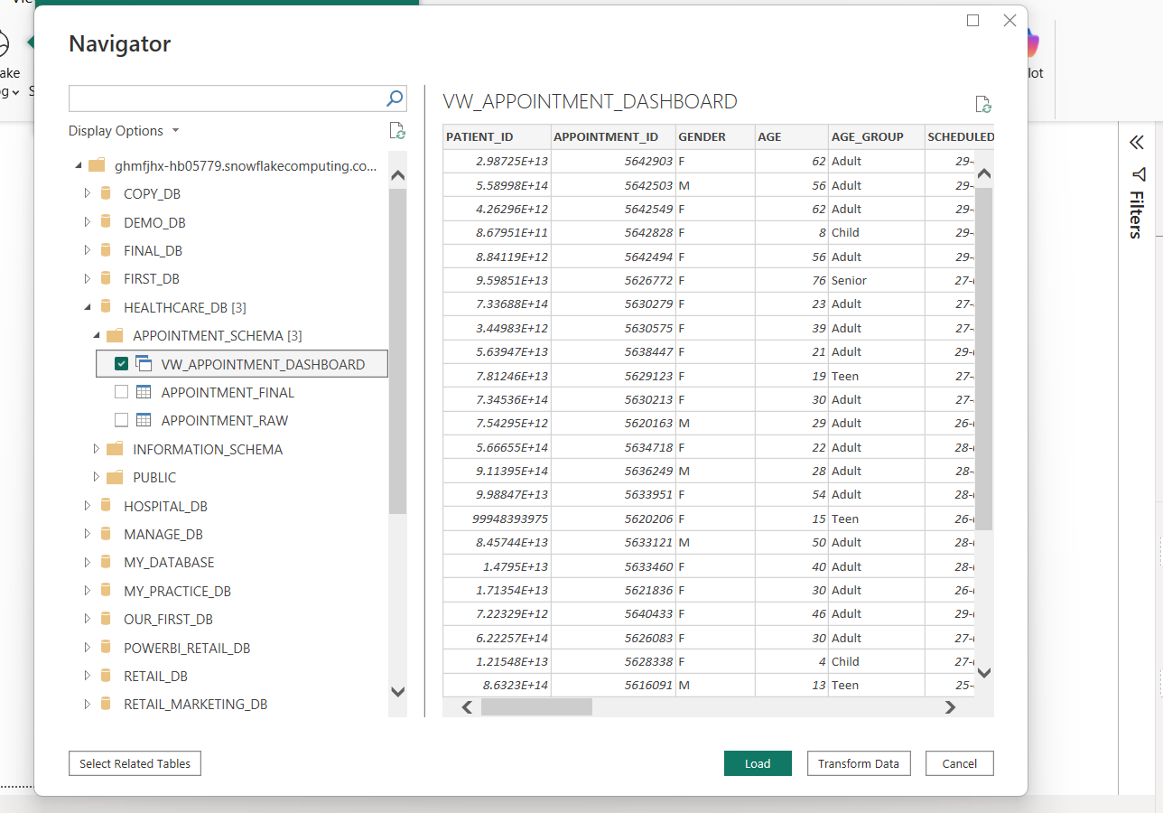

Write the measure
- Total Appointments
Total Appointments = COUNT(VW_APPOINTMENT_DASHBOARD[Appointment_ID])
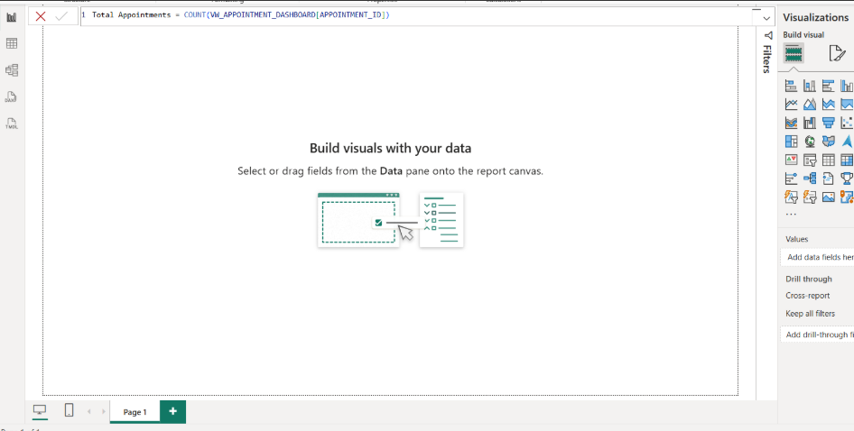
2.Missed Appointments
Missed Appointments = CALCULATE([Total Appointments], VW_APPOINTMENT_DASHBOARD[No_Show_Status] = "Yes")
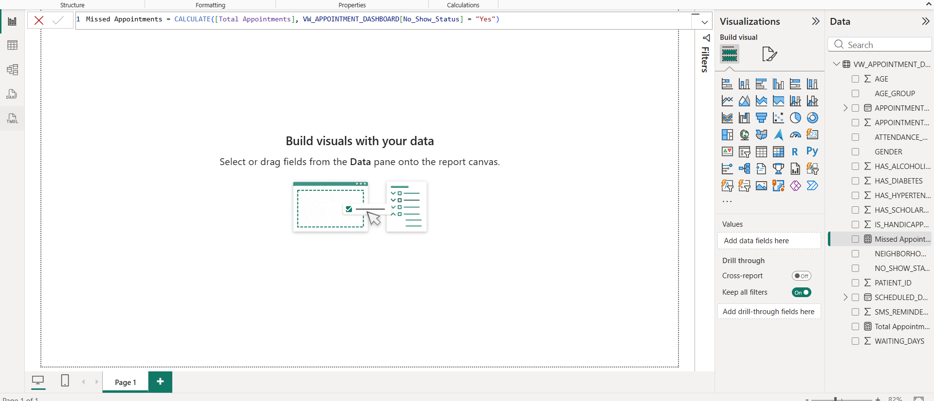

3.visited appointment
Visited Appointments = CALCULATE([Total Appointments], VW_APPOINTMENT_DASHBOARD[No_Show_Status] = "No")
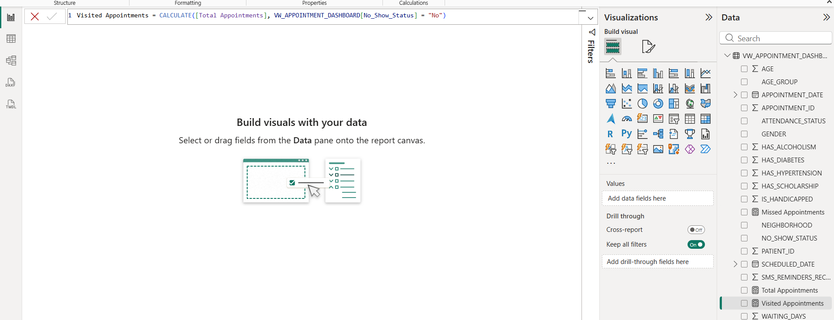
4.No show Rate
No Show Rate = DIVIDE([Missed Appointments], [Total Appointments], 0)
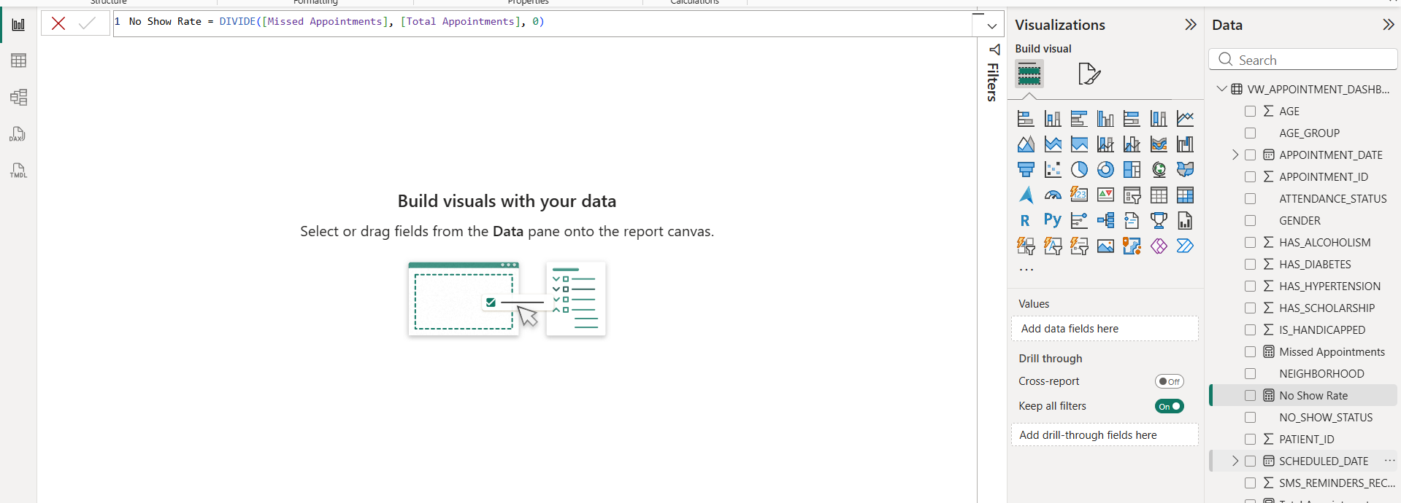
5.Average waiting days
Average Waiting Days = AVERAGE(VW_APPOINTMENT_DASHBOARD[Waiting_Days])
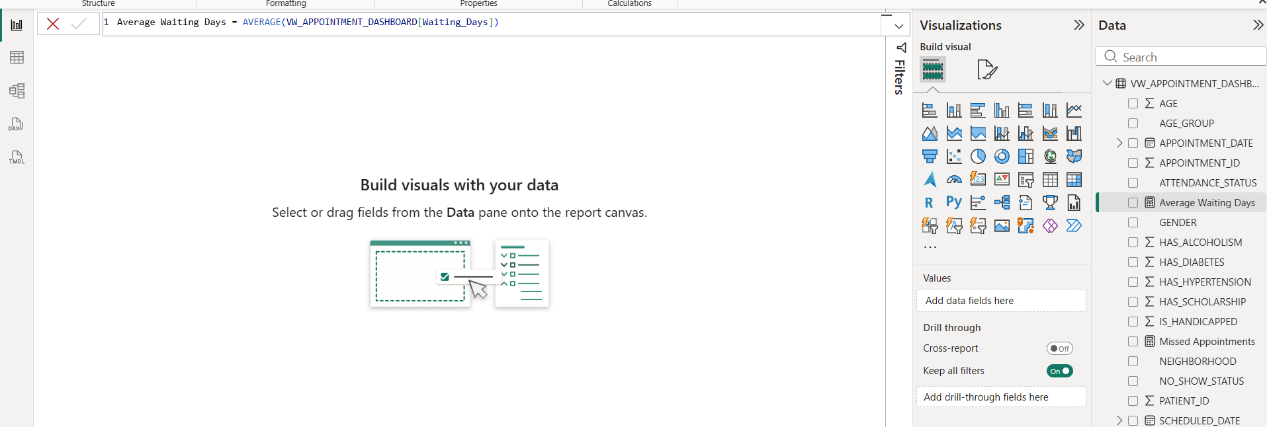

Step A. KPI cards
• Card 1: Total Appointments
• Card 2: No Show Rate
• Card 3: Average Waiting Days
• Card 4: Missed Appointments

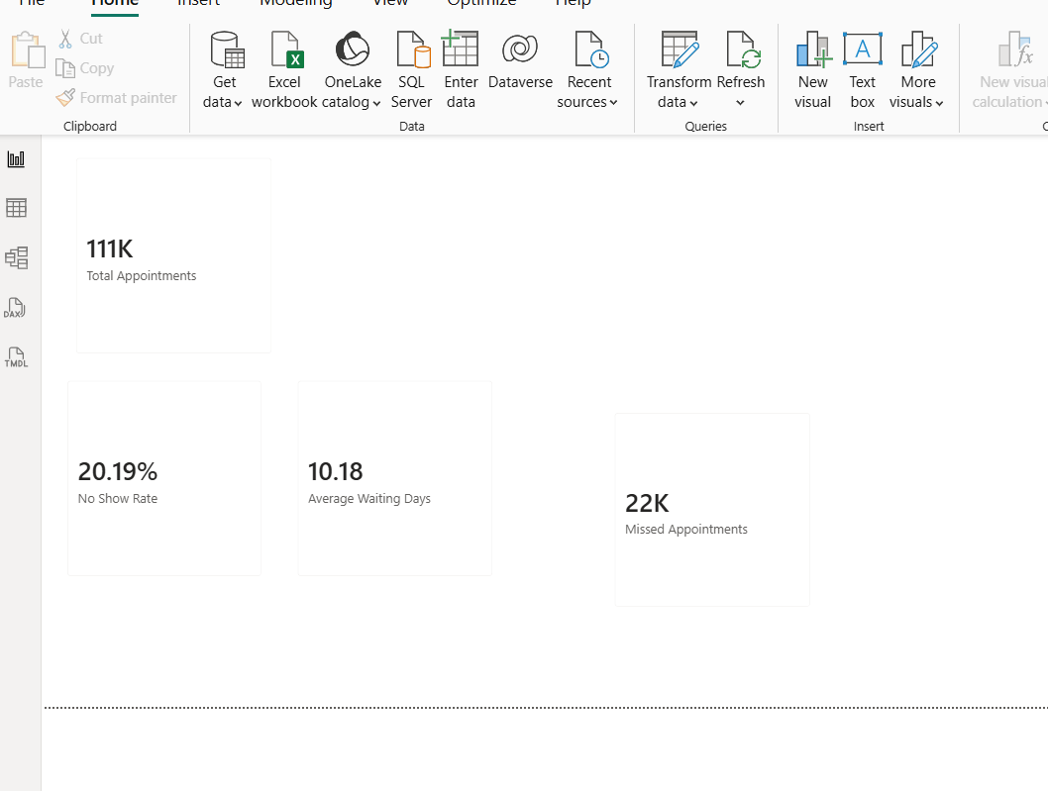

Step B . Build the Attendance Status Distribution
Select donut chart
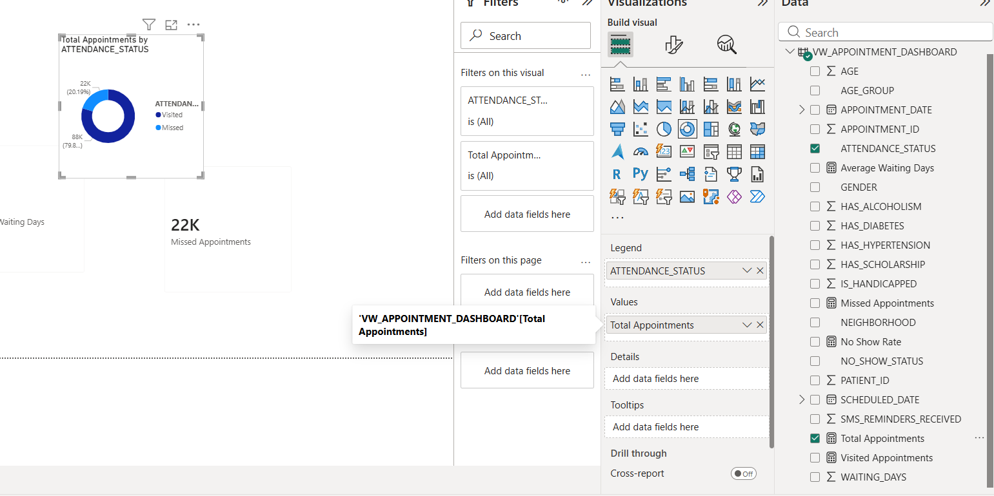
Step C: No-Show by Age Group
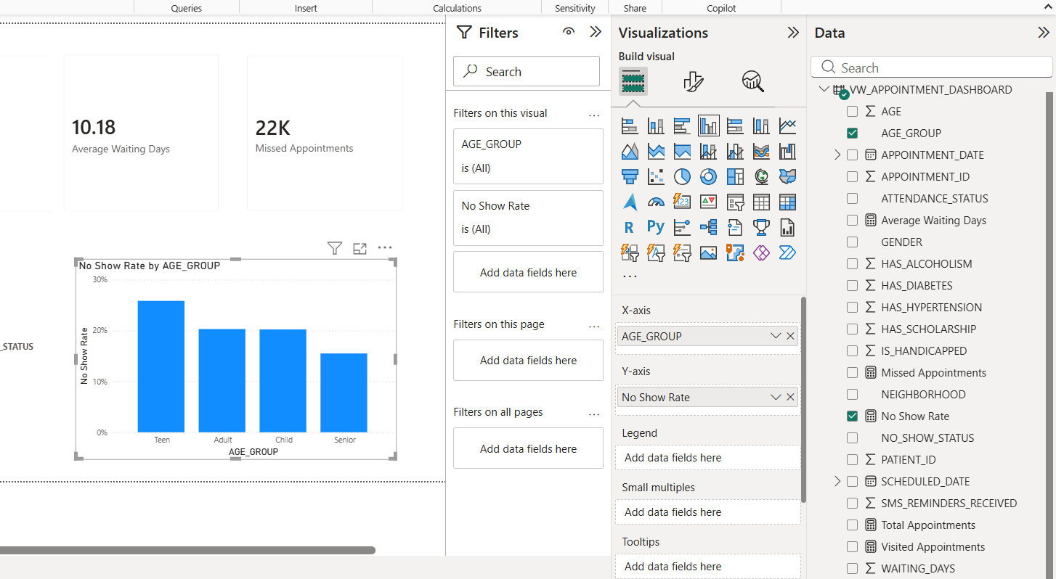

Final 